### Miniature House #9 - Church with a Steeple

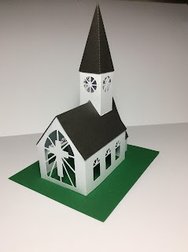

This miniature church model is my favorite. I love the steeple and the church windows. Please leave a comment if you are going to make this model.  
  
I used card stock.

